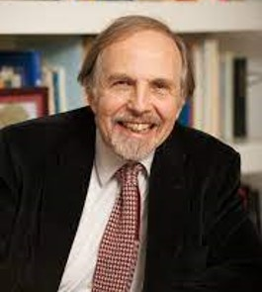
Arthur Kleinman
Director
Principle Investigator

Esther and Sidney Rabb Professor of Anthropology
Professor of Medical Anthropology in Global Health and Social Medicine
Professor of Psychiatry, Harvard Medical School

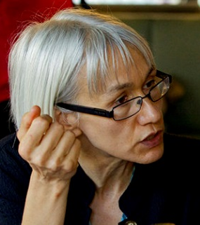
Ann Forsyth

Ruth and Frank Stanton Professor of Urban Planning
Director of the Master in Urban Planning Program
Harvard Graduate School of Design

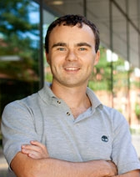
Conor Walsh

Paul A. Maeder Professor
Harvard John A. Paulson School of Engineering and Applied Sciences

Harvard John A. Paulson School Of Engineering And Applied Sciences
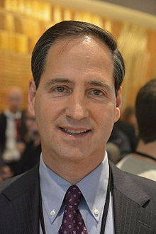
David Bloom

Clarence James Gamble Professor of Economics and Demography
Harvard T.H. Chan School of Public Health


David Perry

Executive Director,
Assistive Technology Initiative at Harvard
John A. Paulson School of Engineering and Applied Sciences

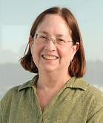
Ellen Seely

Professor of Medicine, Harvard Medical School

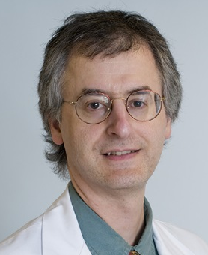

Eric Krakauer

Associate Professor, Harvard Medical School
Directs the Global Palliative Care Program
Massachusetts General Hospital

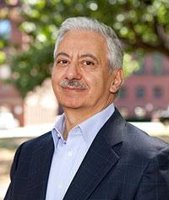

Fawwaz Habbal
Co-director

Executive Dean for Education and Research,
Harvard John A. Paulson School of Engineering and Applied Sciences


Hongtu Chen
Co-director

Assistant Professor of Psychology
Harvard Medical School

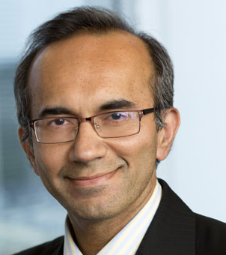
Tarun Khanna

Jorge Paulo Lemann Professor
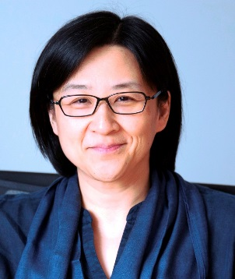
Harvard Business School

Winnie Yip

Professor of the Practice of Global Health Policy and Economics
Harvard T.H. Chan School of Public Health

